Bug_01:
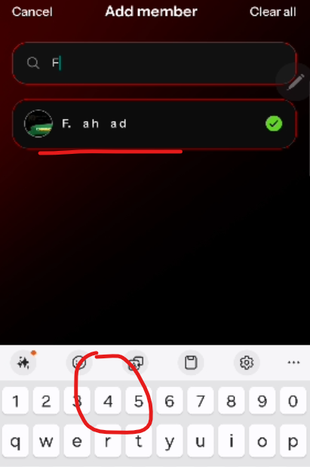
After selecting the member, the keypad should be close.
Bug_02:
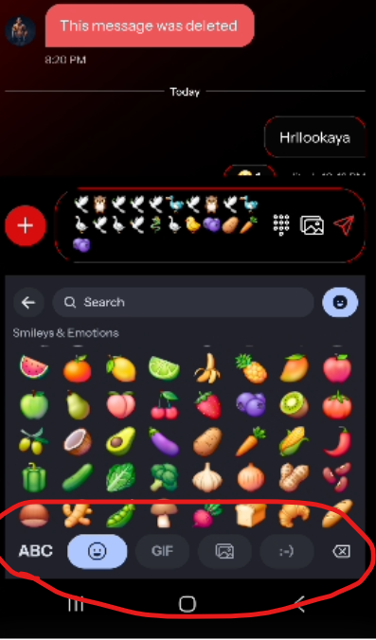
Not functional
Bug_03:
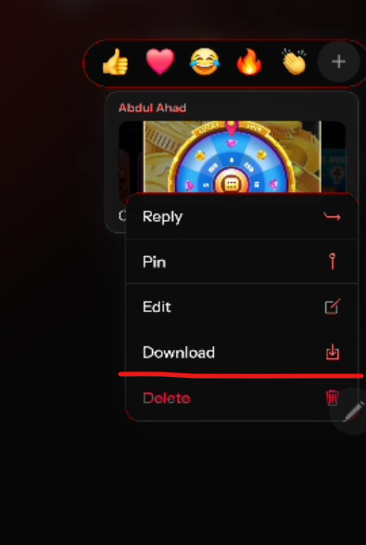
not downloading the image

Bug_4:
Before deleting any message, the confirmation message should be appear, like “ This message will be deleted from you/everyone”
Bug_5:
When Coach add any member in group, the message should be display “you added fahad”.

Bug_6:
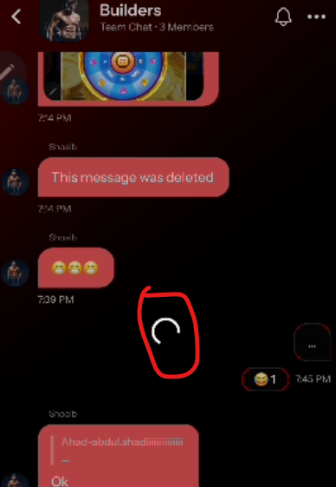
Loading when react or changing the emoji

Bug_7:
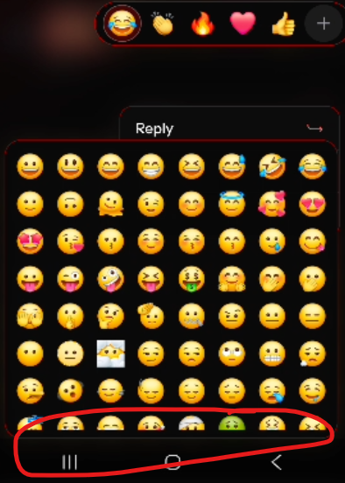
Emoji section missing

Bug_8:
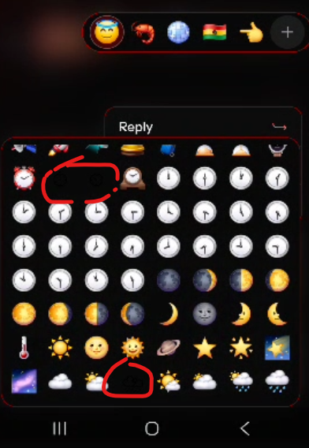
Emoji’s missing on many diff places

Bug_9:
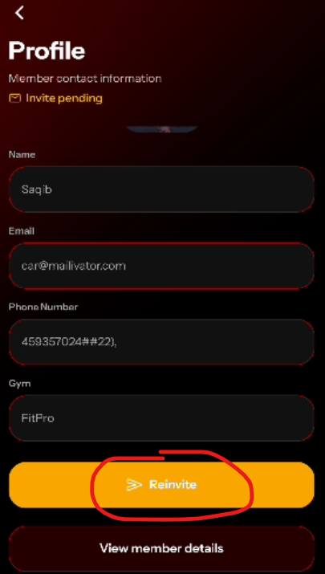
After reinviting any member, it should not allow user to reinvite again instantly

Bug_10:
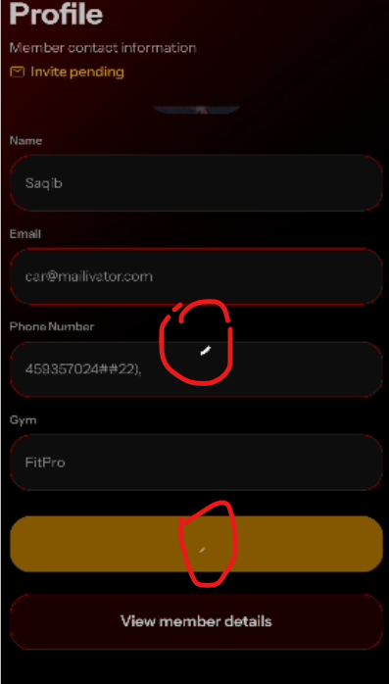
Dual loading sign
Bug_11:
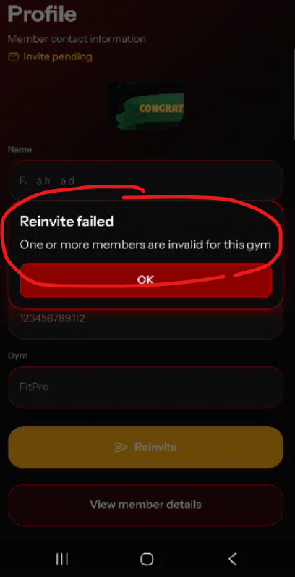
Wrong error message, when group invitation sent to inactive member

Bug_12:
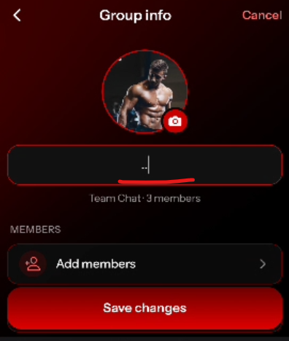
No validation on edit group name
Bug_13:
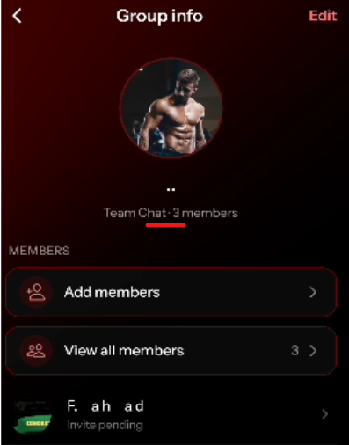
Dot (.) is not required

Bug_14:
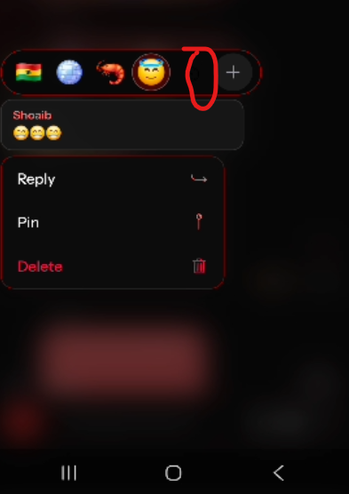
Emoji missing
Bug_15:
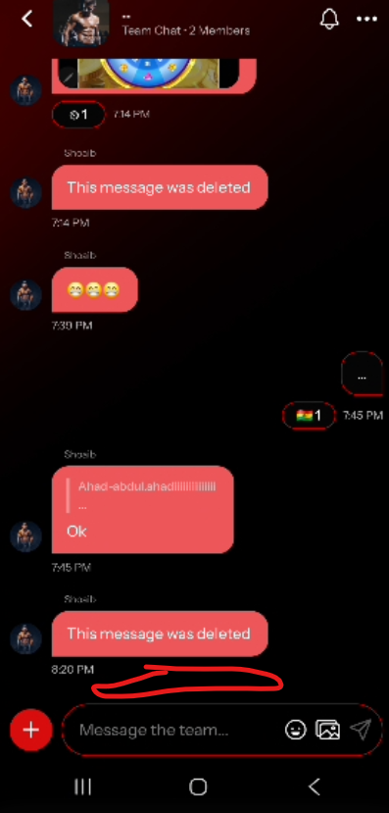
When admin remove any member from group, it should show you removed member1

Bug_16:
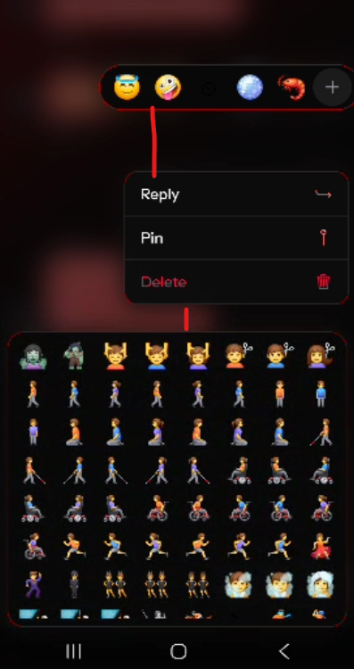
Unusual gap
Bug_17:
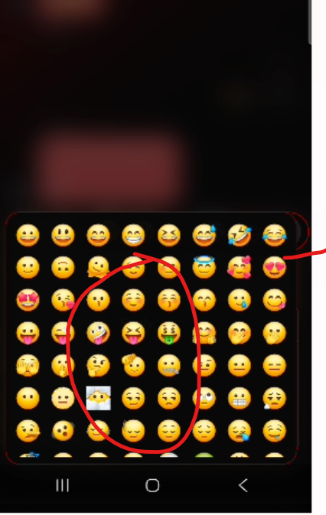
Emoji’s not scrolling on new message and also overlap

Bug_18:
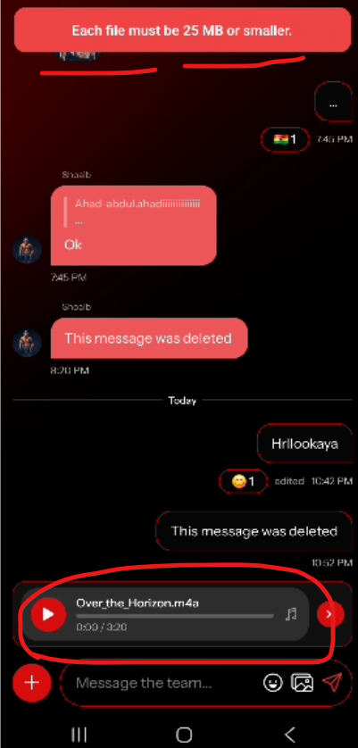
When file size exceeded, file should be removed from bottom
Bug_19:
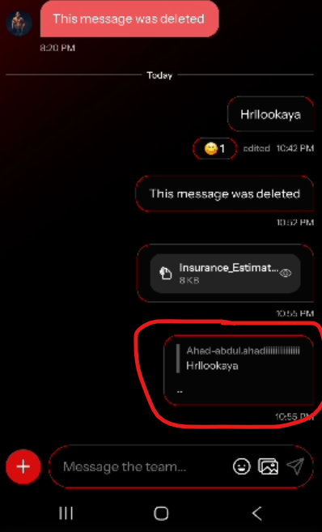
When try to react on this message, have to click on border instead of anywhere on the message.

Bug_20:
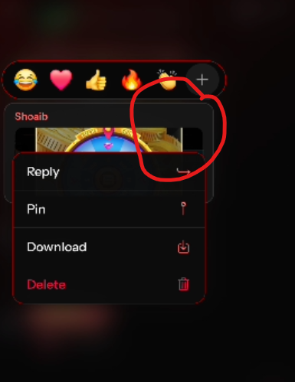
When try to react on pic, it overlap with picture
Bug_21:
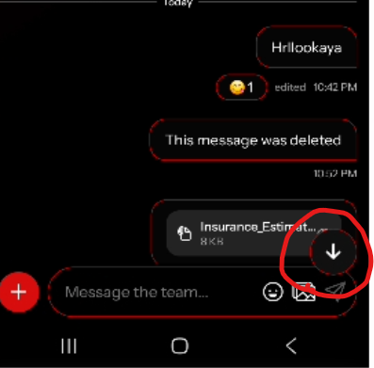
Overlap issue

Bug_22:
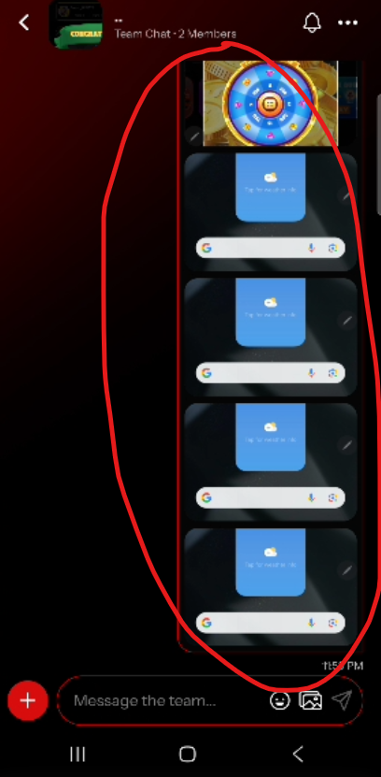
It shouldn’t not show like this when user upload multiple pic’s

Bug_23:
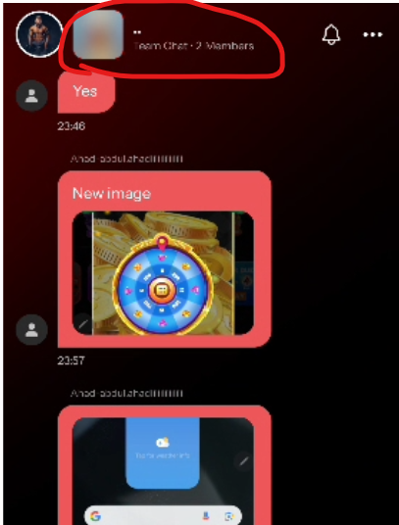
On Student App, Member should be able to see the group image

Bug_24:

When user click on any pic, the pic should be swipe left and right to see other pics in chat

